The Impact Your Interest Rate Makes [INFOGRAPHIC]
by The KCM Crew

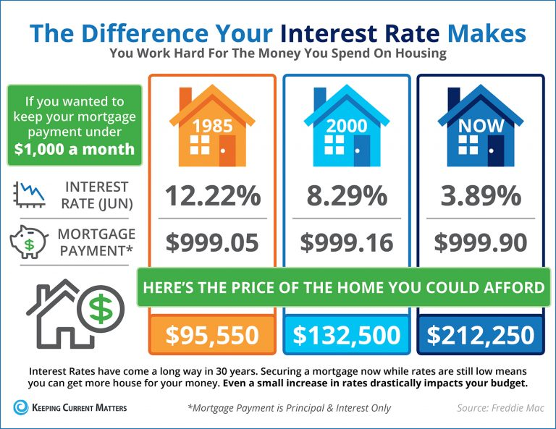

Some Highlights:
- Interest rates have come a long way in the last 30 years.
- The interest rate you secure directly impacts your monthly payment and the amount of house that you can afford if you plan to stay within a certain budget.
- Interest rates are at their lowest in years… RIGHT NOW!
- If buying your first home, or moving up to the home of your dreams is in your future, now may be the time to act!

